C12-15 Pareth-9
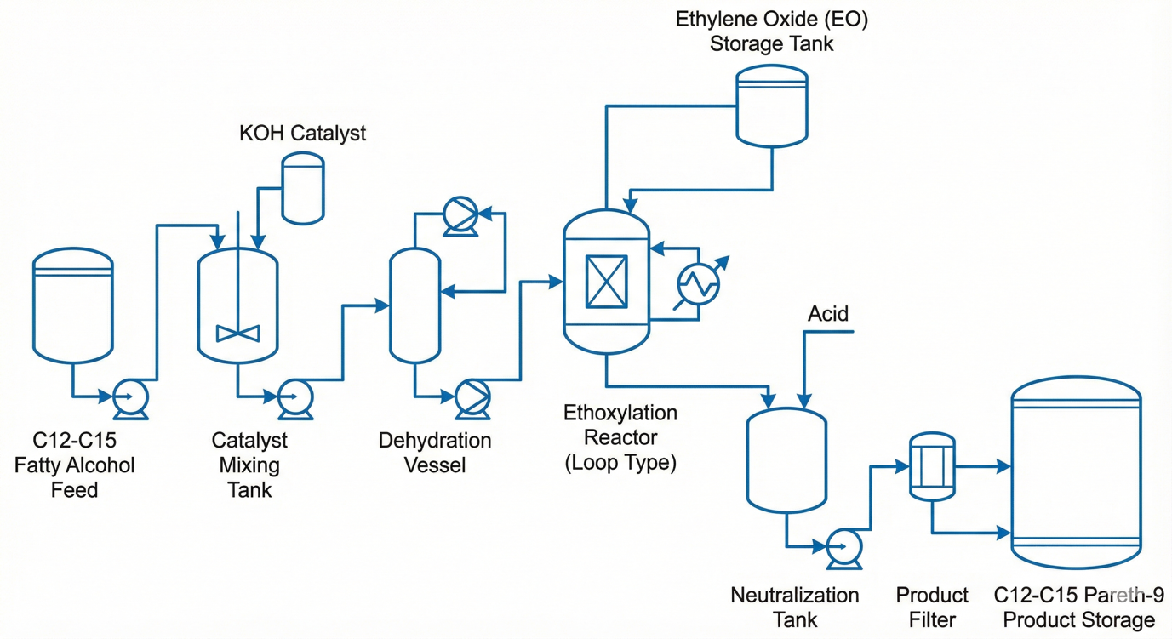

Equipment list

Based on the Process Flow Diagram (PFD) provided and the industrial brochure, here is the breakdown of the Ideal Equipment versus Five Alternative Options for each major unit operation.
Efficiency is measured by the equipment's ability to maintain uniform composition, handle heat-sensitive substances, and ensure overall process efficiency.

1. Catalyst Mixing (Catalyst Mixing Tank)
The goal is to premix fatty alcohols with the KOH catalyst to create a uniform feed.
- Ideal Equipment: Continuously Stirred Tank Reactor (CSTR)
  - Rationale: CSTRs are ideal for liquid-phase reactions and allow for easy control of temperature and concentration. They continuously mix reactants to maintain uniform composition.
- 5 Less Efficient Options:
  - Plug Flow Reactor (PFR): Less efficient for initial mixing because it minimizes back-mixing.
  - Fluidised Bed Reactor: Designed for solid beds and gas-liquid suspension, not liquid-liquid catalyst dissolution.
  - Packed Bed Reactor: High resistance to flow and primarily intended for catalytic surfaces.
  - Axial Pump Circulation: Provides flow but lacks the internal agitation required for uniform concentration.
  - Single-Stage Centrifugal Pump: Useful for transfer but cannot maintain a steady-state mixing process within a vessel.

2. Dehydration (Dehydration Vessel)
This step removes water before the ethoxylation reaction to prevent side reactions.
- Ideal Equipment: Agitated Thin Film Evaporator
  - Rationale: It spreads liquid into a thin film on a heated surface, maximizing heat transfer and minimizing residence time, which reduces the risk of thermal degradation for heat-sensitive alcohols.
- 5 Less Efficient Options:
  - Short Tube Vertical Evaporator: Efficient for large volumes but has higher residence times than thin-film types.
  - Long Tube Vertical Evaporator: Rapid vaporization but less effective than agitated systems for viscous alcohol mixtures.
  - Climbing Film Evaporator: Relies on upward motion which may lead to uneven drying of viscous materials.
  - Vacuum Dryer: Designed for solids or semi-solids rather than continuous liquid dehydration.
  - Draft Tube Baffle Crystalliser: Used for crystal growth, not for the evaporation of water from a liquid feed.

3. The Reaction Unit (Ethoxylation Reactor)
This stage requires intense mass transfer between the EO gas and the liquid alcohol¹⁹.
- Ideal Equipment: External Loop Bubble Column
  - Rationale: Features an external circulation loop that enhances gas-liquid interaction and improves mixing efficiency, making it ideal for large-scale operations.
- 5 Less Efficient Options:
  - Internal Loop Bubble Column: Operates with minimal complexity but offers less control over flow patterns than external loops.
  - Standard CSTR: While good for liquids, it lacks the specific gas-sparging efficiency required for high-rate ethoxylation.
  - Packed Bed Reactor: EO can "channel" through the bed, leading to uneven ethoxylation across the alcohol chain.
  - Plug Flow Reactor (PFR): Difficult to manage the high exotherm of ethoxylation in a single pass without back-mixing for temperature control.
  - Fluidised Bed Reactor: Generally used for gas-solid reactions, not gas-liquid ethoxylation.

4. Fluid Transfer (Pumps)
Consistent flow is required between the reactor, neutralization, and filtration stages²⁶.
- Ideal Equipment: Diaphragm Pump
  - Rationale: A positive displacement pump that provides precise flow control and is highly suitable for handling viscous or hazardous fluids like EO-rich mixtures²⁷.
- 5 Less Efficient Options:
  - Single-stage Centrifugal pump: Reliable but less precise for exact dosing or high-pressure requirements²⁸²⁸²⁸²⁸.
  - Axial Pump: Designed for high flow at low pressure; it cannot handle the head pressure required for many process stages²⁹.
  - Single Stage Piston PDP: Accurate, but the pulsing flow is less efficient for continuous filter feeding compared to a diaphragm pump³⁰³⁰³⁰³⁰.
  - 2-stage Centrifugal pump: Provides pressure but lacks the positive displacement accuracy needed for molar-ratio dosing³¹³¹³¹³¹.
  - Rotary Screw Compressor (used as a pump): Inefficient for liquid transfer as it is designed for gas compression³².

5. Final Finishing (Neutralization & Filtration)
The final C12-C15 Pareth-9 must be clear and free of catalyst salts³³.
- Ideal Equipment: Structured Packing (Sulzer) Column
  - Rationale: If the product requires stripping of unreacted EO, Sulzer packing optimizes contact between liquid and vapor phases to ensure a uniform, high-quality product³⁴³⁴³⁴³⁴.
- 5 Less Efficient Options:
  - Pall Rings (Random Packing): Higher resistance and lower surface area than structured packing³⁵³⁵³⁵³⁵.
  - Sieve Tray: Prone to "weeping" at low flow rates, which can compromise product purity³⁶.
  - Bubble Cap Tray: High pressure drop and more complex to maintain than packing.
  - Berl Saddles: Older random packing design that offers less efficient mass transfer than modern structured sheets.
  - Draft Tube Baffle (DTB): Inefficient for final liquid purification as it is designed for controlled crystal growth.

Would you like me to determine the optimal Material of Construction (MoC) for each of these units, choosing from Stainless Steel, Glass Lining, or Teflon⁴⁰?

MOC selection
For the production of C12-C15 Pareth-9, the choice of Material of Construction (MoC) is dictated by chemical compatibility with fatty alcohols, high-pressure Ethylene Oxide, and the basic/acidic nature of catalysts and neutralizers.
Based on the approved materials from the industrial brochure, here are the best options for your plant:

1. Primary Process MoC: Stainless Steel (SS316)
- Application: Ideal for Reactors, Distillation Columns, Mixing Tanks, and Storage¹.
- Why it's the best: SS316 offers superior corrosion resistance compared to carbon or mild steel². It is essential for maintaining the "water-white" clarity of surfactants by preventing metal contamination and rust. It also handles the high-pressure requirements of ethoxylation reactors effectively³³³³.

2. Corrosion-Resistant Lining: Glass Lining
- Application: Ideal for Dehydration Vessels and Evaporators⁴⁴⁴⁴.
- Why it's the best: Glass lining provides an extremely smooth, non-reactive surface that prevents the "sticking" or fouling of fatty alcohols⁵⁵⁵⁵. It is particularly useful in vacuum systems where heat-sensitive materials are processed at high temperatures⁶⁶⁶⁶.

3. Specialized Chemical Lining: Teflon (PTFE) Lining
- Application: Ideal for Diaphragm Pumps, Dosing Skids, and Transfer Lines⁷⁷⁷⁷.
- Why it's the best: Teflon is almost entirely chemically inert⁸⁸. Since Ethylene Oxide is a highly reactive gas, using Teflon-lined components ensures there is no material degradation or hazardous chemical reaction with the equipment seals and linings⁹.

4. Cost-Effective Non-Process MoC: Carbon Steel / Mild Steel
- Application: Suitable only for Utility Lines (like compressed air or cooling water) or Structure Support¹⁰.
- Why it's the best: While cheap, these materials are generally not recommended for the main Pareth-9 process because they can lead to product discoloration and are prone to corrosion from industrial catalysts¹¹.

Utilities
Based on the "Utilities" section in your provided reference brochure¹, here is a specialized utility design for the production of C12-C15 Pareth-9. These utilities are essential for maintaining thermal stability during the highly exothermic ethoxylation reaction and for high-vacuum processing²²²².

Utilities Selection for C12-C15 Pareth-9 Plant

1. Thermic Oil System
- Equipment: Thermic Oil Heater & Closed-loop Pump Skid³.
- Function: Provides high-temperature heat transfer for the Agitated Thin Film Evaporator and the initial heating of the CSTR Catalyst Mixing Tank⁴.
- Why it's Ideal: It operates at high temperatures ($>200^\circ C$) without the high pressurization required by steam systems, making it safer for stable thermal control in chemical processing⁵.
- Specifications: 140 litres provided⁶. Base Price: ₹18,000⁷.

2. Chilled Water System
- Equipment: Industrial Chiller Unit⁸.
- Function: Used in the External Loop Reactor's heat exchanger to remove the massive heat of the reaction quickly⁹.
- Why it's Ideal: Standard cooling water is often insufficient to control the peak exotherm of Ethylene Oxide addition; chilled water ensures consistent low temperatures to prevent thermal runaway¹⁰.
- Specifications: 150 kg provided¹¹. Base Price: ₹12,500¹².

3. Nitrogen Generation System
- Equipment: Centrifugal or Axial Compressor (for N2 Plant)¹³¹³¹³¹³.
- Function: Provides a continuous supply of compressed air to a PSA Nitrogen generator for reactor blanketing and purging¹⁴¹⁴¹⁴¹⁴.
- Why it's Ideal: Maintaining an oxygen-free environment is the primary safety requirement for handling Ethylene Oxide. Axial Compressors are ideal here as they handle large volumes efficiently with a small footprint¹⁵.
- Base Price: ₹25,000¹⁶.

4. Steam Utility
- Equipment: Short Tube or Falling Film Heat Exchanger¹⁷¹⁷¹⁷¹⁷.
- Function: Acts as a heat carrier for secondary heating and sterilization of the Product Filter and Storage Tanks¹⁸.
- Why it's Ideal: Steam is widely used in chemical processes where significant thermal energy is required for viscosity reduction in finished surfactants¹⁹.
- Specifications: 4 MT provided²⁰. Base Price: ₹8,000²¹.

5. Cooling Water (General Purpose)
- Equipment: Cooling Tower & Single-stage Centrifugal Pump²²²²²²²².
- Function: Circulates water to absorb and remove excess heat from auxiliary equipment like pump seals and compressor intercoolers²³.
- Why it's Ideal: Simple and reliable for general heat dissipation where precise "chilled" temperatures are not required²⁴.
- Specifications: 150 kg provided²⁵. Base Price: ₹7,500²⁶.

Summary Table of Utility MoCs & Costs
Utility | Critical Component | Recommended MoC | Base Price
Thermic Oil | Closed-loop Pipes | Carbon Steel ²⁹ | ₹18,000
Chilled Water | Heat Exchanger | Stainless Steel (SS316) ³⁰ | ₹12,500
Nitrogen | Compressor | Mild Steel ³¹ | ₹25,000
Steam | Calandria/Tubes | Stainless Steel (SS316) ³² | ₹8,000
Cooling Water | Circulation Pump | Stainless Steel (SS316) ³³ | ₹7,500
Would you like me to calculate the Total Capital Expenditure (CAPEX) for this utility section combined with the reactors and pumps discussed earlier?

Summary Table of Recommended MoCs
Equipment Category | Ideal MoC / Lining | Rationale
Reactors & Columns | Stainless Steel (SS316) | High pressure and corrosion resistance¹²¹²¹²¹².
Evaporators | Glass Lining | Prevents fouling and handles high vacuum¹³¹³¹³¹³.
Pumps & Seals | Teflon Lining | Chemical inertness for hazardous EO¹⁴¹⁴¹⁴¹⁴.
Crystallisers | Stainless Steel (SS316) | Maintains product purity and uniform quality¹⁵¹⁵¹⁵¹⁵.
Would you like me to calculate the total equipment budget using these specific MoC options and the base prices provided in the brochure?

Introduction
1. Short Info: C12-C15 Pareth-9 for Oil Spills
- What it is: A non-ionic surfactant consisting of a linear fatty alcohol hydrophobic "tail" (a mix of 12 to 15 carbon chain lengths) connected to a hydrophilic "head" of approximately 9 Ethylene Oxide (EO) units.¹
- Common Trade Names: Tergitol 15-S-9 (Dow), Neodol 25-9 (Shell).
- Role in Oil Spills: It acts as a dispersant. When sprayed onto an oil slick, it lowers the interfacial tension between the oil and seawater. This allows wave energy to break the oil blanket into microscopic droplets that disperse into the water column, preventing them from reforming a slick and allowing natural bacteria to biodegrade them.
- Why it is the preferred "Green" choice:
  - Ideal Performance: Its HLB value (~13.3) is optimized for dispersing heavy crude oil into saltwater.
  - Biodegradable: Unlike NPE, its linear carbon chain is easily digested by bacteria, meaning it doesn't persist in the ocean.
  - Low Aquatic Toxicity: It is significantly less toxic to fish and marine life than NPEs and is not an endocrine disruptor.

- 2. Synthesis Process
- The manufacturing process is known as Ethoxylation. It is an exothermic polymerization reaction where highly reactive ethylene oxide gas is added to a fatty alcohol base.

$$Fatty Alcohol \left(R-OH\right)+n⋅Ethylene Oxide \left(EO\right)→^{cat} Alcohol ethoxylate$$

